Anomaly detection using Fast Fourier Transform (FFT)
# Last amended: 14th Sep 2026
#My folder: C:\Users\ashok\OneDrive\Documents\anomaly_detection\FFT\sensor_data\
# Ref: Knime article here
# Corresponding pdf file is also in the folder
# GitHub place: Under Clustering repo
# Virtual Machine: ubuntu_database under Documents/
#
Contents
Python conda environment: 2
Fourier Transform: 2
Experiments on Colab: 5
What if the signals are aperiodic? 6
What is Fast Fourier Transform? 6
How is FFT used for anomaly detection? Give brief numerical example? 7
Sensor data 8
Problem: 8
How does FFT help: 8
Model building 9
Testing Bad Data 9
Knime Workflow: 11
Data node-by-node 11
Why is each data point matched to ‘corresponding’ frequency? 12
Would freq of normal and bad data be the same? 19
Why do I always get discrete frequency output in FFT? 20
Finance data 21

Python conda environment:
On every machine create conda python environment as below. Here 5.12 is the version of my KNIME.
conda create --name knime_env -c knime -c conda-forge knime-python-scripting=5.12 python=3.11
Preferences-> Python->conda and select your environment.

Fourier Transform:
The Fourier transform translates a signal from the time domain (how it changes over time) into the frequency domain (the individual frequencies that make it up).
A classic analogy is thinking of a musical chord: the original sound wave is the time domain, while the individual musical notes (frequencies) and their volumes make up the frequency domain.
🔄 Time Domain vs. Frequency Domain
Feature | Time Domain (f(t)) | Frequency Domain (F(ω))
What it shows | Amplitudes shifting over chronological time. | The strength (magnitude) and phase of each frequency pitch.
Visual representation | A standard waveform graph (e.g., an audio wave). | A spectrum graph showing spikes at specific frequencies.
Common Use | Recording audio, viewing voltage drops over time. | Equalizing audio, filtering noise, compression.

All the following signals are periodic.
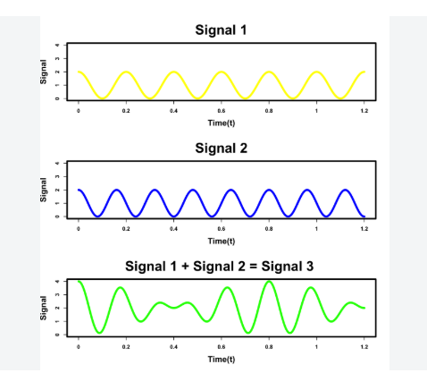
Both Signal1 and Signal2 have the same frequency. But there is phase shift.
Figure 1: Fourier Transform would break Signal3 into two sinusoidal waves, each having one fixed frequency. Signal 3 is sum of just two signals: Signal 1 and Signal2.

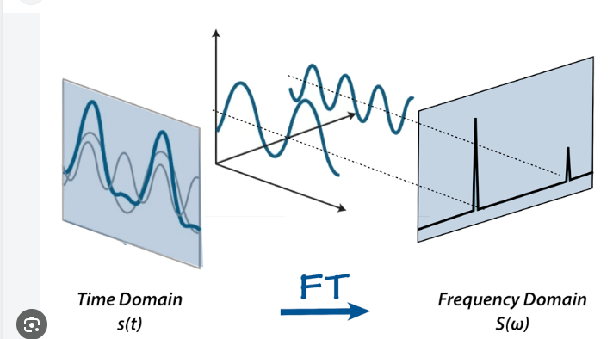
Figure 2 : The rightmost diagram is Frequency vs Amplitude (or Power)In the X-axis of frequency domain is NOT time but frequency.

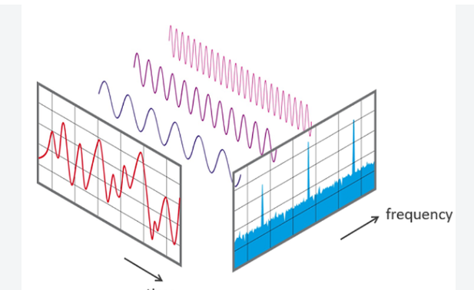
Figure 3: Interpret this as follows: This signal is sum of three sine-waves, each one of fixed frequency. But there may also be multiple frequencies of very low-amplitude also as per the hazy bottom.

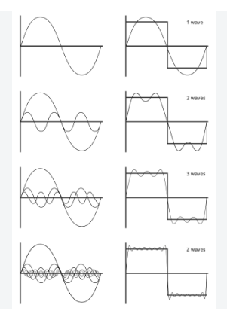
Figure 4: A square wave on the right being successively represented by a series of sine waves but of fixed frequencies.

Experiments on Colab:
If possible, create experiments on Colab/Claude Desktop or Google AI drawing up phase shifted sine waves and adding them up. Here are my prompts in Google Colab:
Starter prompt:
Generate two phase-shifted sinewaves of equal amplitude and add them up to create a third sine wave.
Then, I changed wave phases in the code. The overall wave is still a sinewave.
Next prompt
Add a third sinewave to it such that overall wave does not look like a sinewave but a distorted wave.
Next prompt:
Plot the Fast Fourier Transform (FFT) of the final distorted wave
Next prompt:
But it has only two frequencies as against three we added? Why?
Answer:
That's a great observation! The reason you're seeing only two dominant frequencies in the FFT plot, even though we generated three sine waves, is due to how frequencies combine.
- The first two sine waves (sine_wave_1 and sine_wave_2) both have a frequency of 1.0 Hz. When two sine waves of the same frequency are added together, they combine into a single resultant sine wave that still has that same fundamental frequency (1.0 Hz), but with a new amplitude and phase.
- The third sine wave (distorting_sine_wave) has a frequency of 3.0 Hz.
So, when we sum all three, the resulting distorted_wave effectively contains two distinct frequency components: one at 1.0 Hz (from the first two waves combining) and another at 3.0 Hz (from the distorting wave). The FFT accurately reflects these two underlying frequency components in the final signal.
Next Prompt:
Can you create three aperiodic signals and add them up?
Answer:
Certainly! I will generate three different types of aperiodic signals, add them together, and then visualize both the individual signals and their combined output, including its FFT.
Next Prompt:
Just write the FFT's output as a set of data points in a table.
Answer
Certainly! Here's the Fast Fourier Transform (FFT) output of the summed aperiodic wave presented as a table, showing the frequency, magnitude, and phase angle.
The Fast Fourier Transform (FFT) output for the summed aperiodic wave has been successfully generated and presented in a tabular format. Here are the first few rows of the FFT data:
Frequency (Hz) | Magnitude | Phase (radians)
0.0 | 124.910263 | -0.000000
0.2 | 82.704781 | 2.880392
0.4 | 75.990989 | -0.163212
0.6 | 47.161324 | -3.028479
0.8 | 40.108188 | -0.056551
This table shows the frequency, magnitude, and phase for each component of the FFT. If you'd like to see more of the data, let me know!

What if the signals are aperiodic?
The short answer is: The Fourier transform is actually specifically designed for non-periodic signals.
If a signal is periodic (repeats forever), we use Fourier Series, which breaks the signal down into a discrete set of specific, isolated frequencies. But if a signal is non-periodic (a transient pulse, a one-time event, or random noise), we must use the Fourier Transform, which maps the signal across a continuous spectrum of frequencies.
Here is how the transition works conceptually and mathematically:
From Periodic to Non-Periodic
To understand a non-periodic signal, mathematicians imagine a periodic signal and stretch its repetition period T out to infinity.
- Fourier Series (Periodic): Because the signal repeats regularly, the frequencies involved are perfectly spaced harmonics (e.g., 100Hz, 200Hz, 300Hz). The spectrum looks like a series of isolated spikes (lines).
- Fourier Transform (Non-Periodic): As the period approaches infinity, the gap between these harmonic frequencies shrinks to zero. Instead of isolated spikes, the spikes blend together perfectly to form a smooth, continuous curve.

What is Fast Fourier Transform?
The Fast Fourier Transform (FFT) is not a new mathematical transform; it is simply a highly efficient algorithm used to compute the Discrete Fourier Transform (DFT).
While the standard mathematical formula for the DFT is too slow for real-world computers to calculate in real time, the FFT uses clever mathematical shortcuts to compute the exact same result in a fraction of the time. It is widely considered one of the most important algorithms of the 20th century because it made digital signal processing practical.

⚡ Why the FFT is a Game Changer: Speed
To understand why the FFT is special, you have to look at its computational complexity (how much work a computer has to do as the signal gets longer). If your signal has N data points:
- Standard DFT: Has a complexity of O(N²). If you double the number of data points, the computer has to do four times as much work.
- FFT Algorithm: Has a complexity of $O(N \log N)$. It breaks the problem down recursively, drastically cutting down on repetitive calculations.

How is FFT used for anomaly detection? Give brief numerical example?
"Anomaly detection" refers to identifying deviations from normal patterns in signal data.
The FFT detects anomalies by converting a time-series signal into its frequency components to see if unexpected frequencies appear or if expected frequencies suddenly drop or spike.
While many defects (like a microscopic crack in a rotating motor or a subtle heartbeat irregularity) are nearly invisible in a messy timeline graph, they stick out in the frequency domain like a sore thumb.

🔍 The 3-Step Detection Process
- Establish a Baseline: Run the FFT on a system operating normally. Note which frequencies are present and how strong they are (their "normal" amplitude envelope).
- Monitor Live Data: Continuously take small time windows of live data and run an FFT on them.
- Threshold Checking: Compare the live frequency spectrum against the baseline. If an unauthorized frequency spikes past a set threshold, flag it as an anomaly.

🔢 Brief Numerical Example
Imagine we are monitoring a cooling fan in a server rack. Under normal conditions, the fan spins at a steady speed, creating a predictable vibration wave.
1. Normal State (Baseline)
Suppose our live data gives us a clean wave, and running an FFT on 4 data samples yields the following frequency amplitudes:
- 0 Hz (DC offset): 0.1
- 10 Hz (Fan rotation speed): 5.0 (This is our expected, strong spike)
- 20 Hz (Harmless minor vibration): 0.2
- 30 Hz (High-frequency background noise): 0.1
Rule set: If any frequency amplitude other than 10 Hz goes above 1.5, sound an alarm.
2. Abnormal State (The Anomaly)
A tiny piece of dust chips one of the fan blades. To the naked eye or a simple timeline sensor, the fan is still spinning and pulling power normally. However, the chipped blade causes a tiny, rapid wobble every time it spins.
We take a 4-sample snapshot of this new vibration wave and compute the FFT. The new amplitudes are:
- 0 Hz: 0.1
- 10 Hz: 4.8 (Normal fan speed is slightly lower due to drag)
- 20 Hz: 0.3
- 30 Hz: 2.4 🔴 [ANOMALY DETECTED]
💡 The Verdict
Because the 30 Hz frequency jumped from 0.1 to 2.4 (crossing our safety threshold of 1.5), the algorithm immediately flags a physical defect in the fan blade—long before the machine actually overheats or breaks down.

Sensor data
Once a machine is bad, it continues to emit bad sensor signals. So, this anomaly detection process is NOT to detect a point as anomalous BUT the whole batch as anomalous.

Problem:
We have a machine fitted with several sensors. We have time-wise data from each sensor when the machine had no problems. That is state is normal.
Suddenly, a noise is being emitted by a part of machine. Corresponding sensor is AccelerometerX. The problem is to predict if the data being emitted by AccelerometerX is anomalous.
We have two files:
a) anomalous_machine_data.csv. AND
b) non_anomalous_machine_data.csv
Data points are: 8971 AND 8193.

How does FFT help:
FFT takes a fixed number of time-series points of a signal. Number of these points is a power of 2 i.e. 2^{n}. In our case, we take 512 time-points. FFT examines this complete time series of 512 points and tells us what all sine-wave frequencies and their amplitude would be able to reconstruct it.
We take many batches of these 512 samples. For each one them, we get amplitudes of sine-waves (of the same frequencies). Thus, for every single frequency, across the batches, we have different amplitude values. Mean of these values is taken as also variance.

Model building
Here is the process. FFT only accepts time-samples of size 2^{n} , so we first take a time sample of 4-points i.e. 2² points per sample. We feed into FFT, one batch at a time. As we have a total of fourteen such points, we break them into batches—and remaining two points are discarded.
Let signal frequencies and their amplitudes for the three batches, as analysed by FFT, be as below:
frequency | amp1 | amp2 | amp3
0.2 | 2 | 2.1 | 1.9
0.4 | 1 | 1.2 | 0.8
0.6 | 3 | 2.8 | 3.1
0.8 | 0.9 | 1.1 | 0.8
Note that FFT does also output phase-shift information. But we are not using it but throwing it away. Why do I get discrete frequency output in FFT? Here in steps of 0.2. See below for an answer. Next, calculate mean & variance, row-wise or freq-wise. So now we have:

frequency | amp1 | amp2 | amp3 | mean(amp) | var(amp)
0.2 | 2 | 2.1 | 1.9 | 2.00 | 0.0066667
0.4 | 1 | 1.3 | 0.8 | 1.03 | 0.0422222
0.6 | 3 | 2.8 | 3.1 | 2.97 | 0.0155556
0.8 | 0.9 | 1.1 | 0.8 | 0.93 | 0.0155556

Testing Bad Data
We now take (only) one sample of time-series (of 4-pts) about which we want to find, if it is anomalous or not. As before, our time-series data would have only four points. After FFT transformation our data frequency and amp are as below:
frequency | ampx
0.2 | 3.4
0.4 | 2.1
0.6 | 1.8
0.8 | 1.5

We merge, frequency-wise, this data with the last two columns of our earlier calculated data.

frequency | ampx | mean(amp) | var(amp)
0.2 | 3.4 | 2.00 | 0.00666667
0.4 | 2.1 | 1.03 | 0.04222222
0.6 | 1.8 | 2.97 | 0.01555556
0.8 | 1.5 | 0.93 | 0.01555556

Next, we standardise our ampx column using row-wise (calculated) mean and variance, as below.
frequency | ampx | mean(amp) | var(amp) | stdamp
0.2 | 3.4 | 2.00 | 0.00666667 | 17.15
0.4 | 2.1 | 1.03 | 0.04222222 | 5.19
0.6 | 1.8 | 2.97 | 0.01555556 | 9.35
0.8 | 1.5 | 0.93 | 0.01555556 | 4.54

The formula for calculating values in ‘stdamp’ column is:
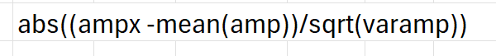
Take the overall mean of this ‘stdamp’ column
mean(stdamp)
9.06

If this mean is >2, we conclude that this batch is anomalous.

Knime Workflow:
Knime workflow file is: ‘Fourier Transform for Anamoly Detection.knwf.’ in the folder given above.
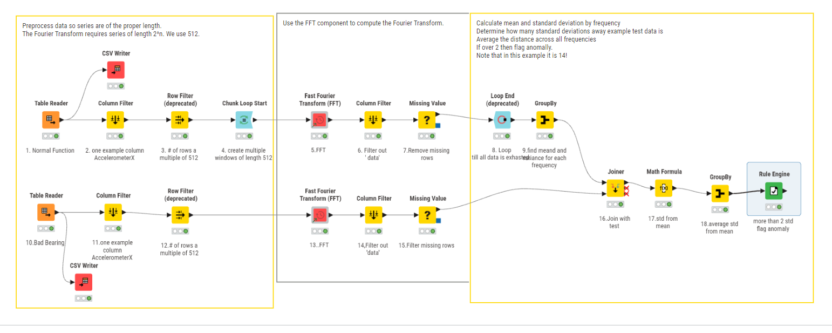

Data node-by-node
In our dataset we have a number of sensors. AccelerometerX is emitting noise and appears to be defective. Before the defect, the pattern of signal was as in is in Node1.

Node1: Original normal data at Node 1:
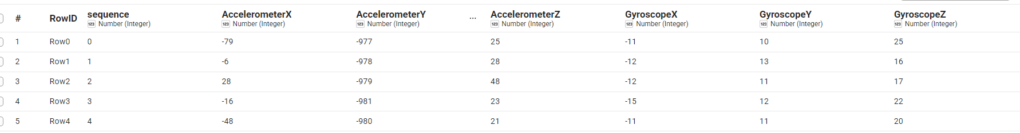

Node2
Node2. Only one column (AccelerometerX) is being examined in this problem. We will find anomaly only through this column:
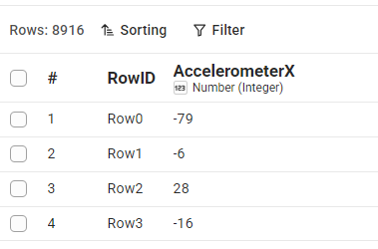

Node3:
Reduce rows so that overall number is a multiple of 512 (some power of 2 ie 2^{n}). The number of data points in an FFT is chosen as 512 because it is a power of 2, which is a strict mathematical requirement for the most common and efficient version of the algorithm (the Cooley-Tukey algorithm).
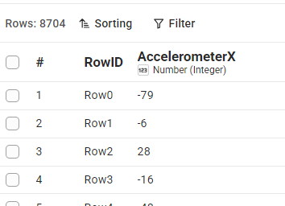
Node4, takes chunk-by-chunk of 512 data points. Transforms this time-varying data to frequency domain per chunk.

Node5:
FFT node outputs as follows:
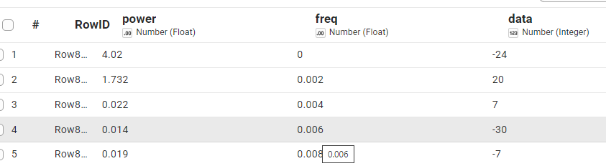
Figure 5: The 'data' column is AccelerometerX data.

Why is each data point matched to ‘corresponding’ frequency?
The table contains 'RowID', 'power', 'freq', and the raw 'data' (AccelerometerX data values). One is confused about why each raw data point seems to line up one-to-one with a specific frequency entry in the output table.
Each data point in the table isn't actually mapping to a single frequency. Instead, what you are looking at is a side-by-side alignment of two entirely separate domains—the time domain and the frequency domain—arranged into a single table for convenience.
When you run a Discrete Fourier Transform (or FFT), the algorithm takes an entire block of time-domain data (e.g., thousands of sequential points from your accelerometer) all at once and transforms them into an entire block of frequency-domain data.
Here is exactly why they appear side-by-side in your table and what that data layout actually means:

🧱 1. Equal Input and Output Sizes
A fundamental rule of the Discrete Fourier Transform is that the number of inputs equals the number of outputs.
- If you feed the FFT algorithm $N$ time-domain samples (your data column),
- It will output exactly $N$ frequency-domain bins (your freq and power columns).
Because the output has the exact same number of rows as the input, data processing software (like KNIME, Excel, or Python dataframes) will naturally display them side-by-side in the same row index (Row8192, Row8193, etc.).

🕰️ Time Domain vs. 🎶 Frequency Domain
The table merges two completely different scales that do not share the same "meaning" per row:
- The data column reads Chronologically: Row 1 (Row8192) is your accelerometer reading at Time = 0. Row 2 is the reading a fraction of a second later, Row 3 is after that, and so on.
- The freq and power columns read Spectral Scale: Row 1 is the power of the 0 Hz component (the static gravity/DC offset of the whole signal chunk). Row 2 is the power at 0.002 Hz, Row 3 is at 0.004 Hz, and so forth.
Therefore, the value 20 in the data column of Row 2 did not produce the 1.732 power at 0.002 Hz. Rather, every single number in the data column combined together mathematically to generate the entire power spectrum column.
If you change just one value in the data column, it will alter the power values across all the rows in the frequency columns, because every frequency bin requires looking at the entire time signal to be calculated.

Node6
Filters out ‘data’ point:
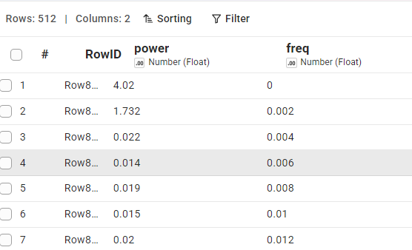

Node 7
Remove missing rows. Number of rows is now reduced to 256 from 512.
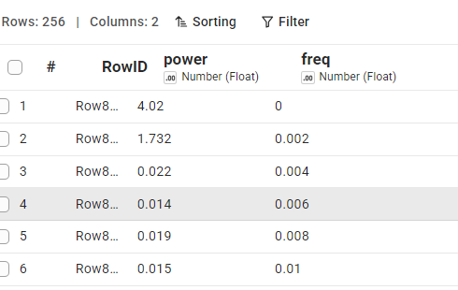

Node8:
Loop until all data in batches of 512 is exhausted. Note also that in every batch, our starting frequency is 0.002 and ending frequency is: 0.248. In the following diagram, we have different values of frequency ‘power’ or frequency amplitude for each one of the 16 interactions (i.e. batches). (16 X 512 = 8192).
Frequency gap is 0.002 i.e. frequencies are: 0.248, 0.246, 0.244….
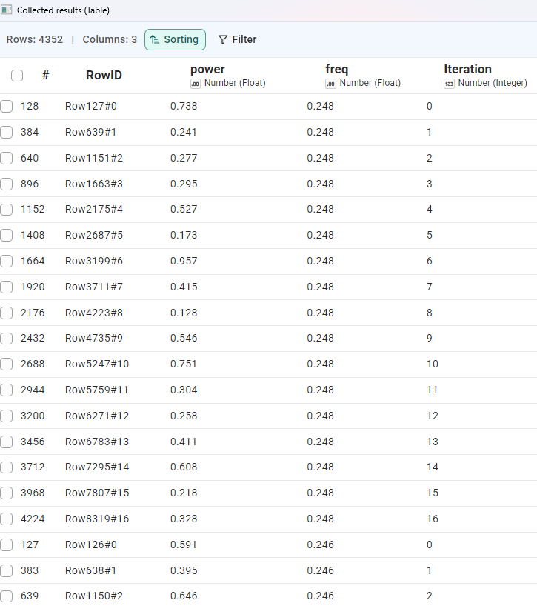
Figure 6: 16 iterations of batch of 512 (i.e. total: 8192). The above table gives frequency-amplitude observed in each iteration for frequency of value=0.248.

Node9:
Calculate mean and variance of power (amplitude) over all iterations after grouping by frequency.
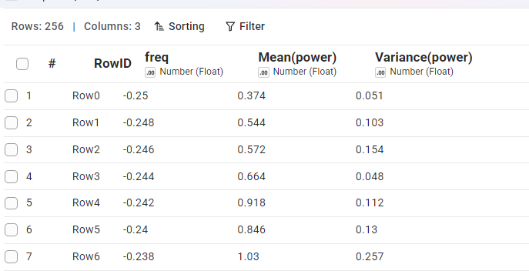

Lower arm
Here we input a batch of 518 pts of defective bearing. Transform it using FFT. For every frequency we calculate ‘power’ or amplitude.

Node 10:
Bad bearing data is input. Emitted data will remain bad till bearing is replaced.
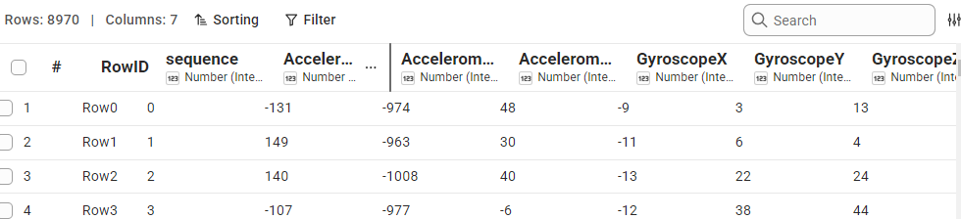

Node11:
Filter out only AccelerometerX data
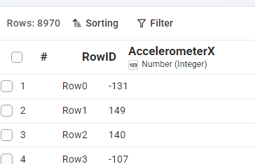

Node 12:
Just take top 512 points.
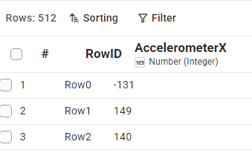

Node 13:
FFT output:
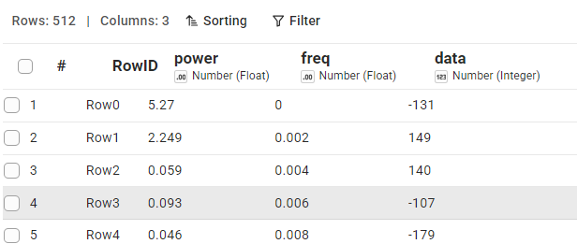

Node 14:
Remove ‘data’ column

Node 15:
Filter missing values
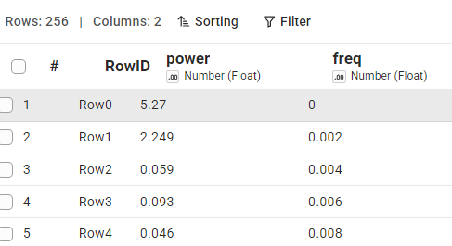

Node 16
Join the top data with bottom data on ‘frequency’.
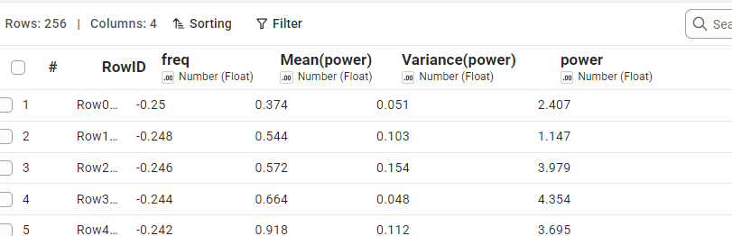

Node 17
Standardise ‘power’ column’ and call it ‘delta’. Standardise as:
delta = Row wise Std power Value = (power – Mean(power))/Sqrt(Variance(power))
Here, per row:
Power: Last column value (say: 2.407)
Mean(power): Mean(power) column value (say: 0.374)
Variance(power): IInd last column (say: 0.051).
The last column ‘delta’ below contains this per-row-value.
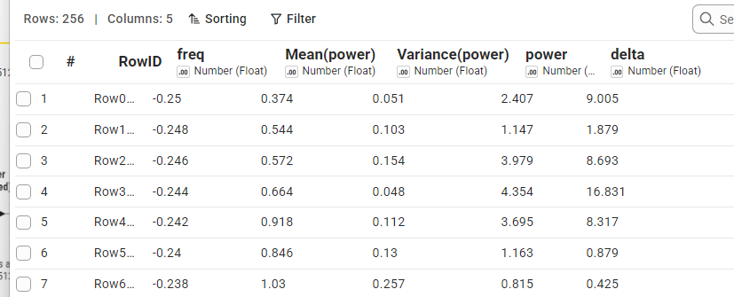

Node 18:
Take a mean of ‘delta’ column.



Node19:
IF it is greater than 2, call the COMPLETE BATCH ‘anomaly.’
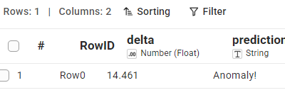
Figure 7: Complete batch is anomalous.

Would freq of normal and bad data be the same?
In our problem, they are. But no.
No, you do not assume they will have the same frequencies. In fact, the entire power of using the FFT for anomaly detection relies on the expectation that normal data and bad data will look completely different in the frequency domain.
When a system transitions from a normal state to an anomalous (bad) state, its frequency signature changes in one of three ways:
1. New, Unexpected Frequencies Appear (Most Common)
Physical defects often introduce brand-new vibration or electrical frequencies that simply do not exist when the machine is running smoothly.
- Normal Data: A cooling fan rotates cleanly. The FFT shows only one major spike at 10 Hz (the rotation speed).
- Bad Data (Anomaly): A bearing wears out, causing a rapid, microscopic rattle. The FFT suddenly shows the healthy 10 Hz spike, plus a brand-new, high-frequency spike at 120 Hz.
2. Expected Frequencies Shift in Amplitude (Spike or Drop)
Sometimes, the frequencies stay the same, but the amount of energy (power) at those frequencies shifts drastically.
- Normal Data: A structural beam vibrates slightly due to ambient wind, showing a tiny power level of 0.2 at 5 Hz.
- Bad Data (Anomaly): The beam develops a structural crack, losing its stiffness. The same wind now causes it to violent shake, pushing the power at 5 Hz up to 8.5.
3. Frequencies Broaden into "Noise"
When components completely fail or break loose, organized, periodic frequencies break down into chaotic, non-periodic energy.
- Normal Data: Clean, sharp spikes at specific frequencies (e.g., a pure musical tone or steady hum).
- Bad Data (Anomaly): The sharp spikes flatten out, and the entire baseline of the graph lifts up, indicating white noise (like the static sound of a broken speaker).

🧠 How the Algorithm Handles This
Because normal and bad data have different frequency profiles, your anomaly detection pipeline will typically use one of two strategies:
- The Threshold Method: You teach the algorithm what normal looks like, and you build a "ceiling" (threshold) across the spectrum. If any frequency—whether it's an existing one or a brand-new one—crosses that ceiling, it flags an anomaly.
- The Machine Learning Method: You train a model (like an Isolation Forest or a neural network) on the FFT output. The model treats the power values of your 512 frequency bins as a unique "fingerprint" and easily learns to tell the healthy fingerprint apart from the broken one.

Why do I always get discrete frequency output in FFT?
Yes, that's exactly how FFT works. Here's why?
FFT gives you discrete frequency bins, not a continuous spectrum
When you feed the FFT algorithm a signal with N samples taken at a sampling rate fs, it doesn't return "the frequency content at any frequency you want." It returns exactly N (or N/2, if you only keep the non-negative-frequency half) discrete frequency bins, spaced evenly from 0 up to the Nyquist frequency (fs/2).
The spacing between consecutive frequency bins is:
Δf = fs / N
So in your table, the fact that freq goes 0, 0.002, 0.004, 0.006, 0.008, 0.01, 0.012... with a constant step of 0.002 is a direct fingerprint of this. That step size is your Δf, which tells you:
fs / N = 0.002
So if you know either your sampling rate or your number of samples, you can back out the other. For example, if N = 512 (matching your row count of 512), then fs = 0.002 × 512 ≈ 1.024.
Why this happens (intuition, not just math)
The FFT is really just evaluating the Discrete Fourier Transform, which assumes your finite chunk of N samples represents one period of a periodic signal. Because of that assumption, the only frequencies that "fit" cleanly into that window are integer multiples of 1/(N·Δt) — i.e., integer multiples of fs/N. Anything in between doesn't correspond to a whole number of cycles across your sample window, so it isn't a valid basis frequency for that particular DFT.
Practical implications
- Frequency resolution is fixed by Δf = fs/N — want finer resolution (smaller Δf)? You need more samples (longer time record), not a fancier FFT.
- Zero-padding (appending zeros to your signal before the FFT) will give you more points and interpolate between the "true" bins, making the plot look smoother — but it does NOT add real new information/resolution. It only makes the existing spectral shape easier to visualize.
- If your actual signal has a frequency component that falls between two bins (e.g., at 0.017 when your bins are 0.016 and 0.018), you'll see energy "leak" into the surrounding bins rather than one clean spike — this is called spectral leakage.

Finance data
# data: C:\Users\ashok\OneDrive\Documents\anomaly_detection\FFT\finance_data
# Source Claude desktop
# Knime file: ‘Fourier Transform for Anamoly Detection--Finance Data’
Prompt:
I have uploaded two csv files. Data in the files has been used in the Anomaly Detection process by Knime. The pdf article which describes the process is also attached. KNIME uses Fast Fourier Transforms for making anomaly prediction. I want a similar time-series data pertaining to finance.

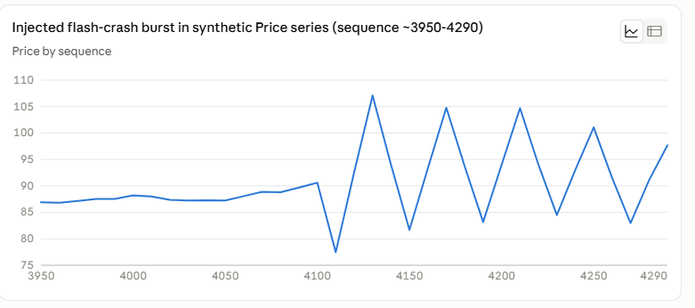
Figure 8: From point 3950 onwards data is anomalous. First, the data values are almost flat (and hence anomalous) and next they burst (and hence again anomalous). But note thisis anomaly is occurring only point 3950 onwards and not earlier.

I generated two finance-flavored CSVs that mirror the structure of your sensor files, so you can plug them into the same KNIME FFT anomaly-detection workflow.
Design (mirrors the turbine example):
- 6 numeric columns per row, like AccelerometerX/Y/Z + GyroscopeX/Y/Z → here it's Price, Return, Volume, Volatility, BidAskSpread, OrderFlowImbalance
- 8,192 rows = 16 × 512, so it slices cleanly into FFT windows of 512 (same window size the article uses)
- non-anomalous_finance_data.csv — a "normal" trading regime: price random-walk plus repeating intraday cycles (a 512-tick cycle for volume/volatility, shorter cycles layered on top, like the turbine's steady vibration signature)
- anomalous_finance_data.csv — identical generative process, but rows 4096–4607 (exactly one 512-window) get a flash-crash-style shock: a decaying high-frequency oscillation injected into every column, the same way the article injects a new vibration frequency for the "bad bearing" data
That shock shows up clearly as a burst of high-frequency energy the FFT wouldn't see in the normal windows:
The chart above shows the injected burst around sequence 4090–4290 — prices whipsaw at a much higher frequency than anything in the normal data, which is exactly the kind of signature the FFT + z-score approach in the article is built to catch.
To reuse the KNIME workflow as-is:
- Point the two CSV Reader nodes at these files instead of the turbine ones
- Pick one column at a time (e.g., Price) for the "one example column" filter, since the workflow processes a single series through FFT
- Keep window size 512 — the anomalous window (rows 4096–4607) should land in exactly one Chunk Loop iteration and score highly
##########

